Boats/Ports Page

GROTON / NEW LONDON
After You Too  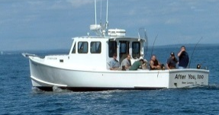 | Capt. Frank Blume | (860) 608-7947 | 6 passenger
Reelin  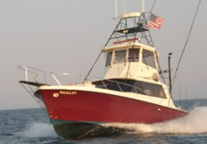 | Capt. Kevin Bentley | (860) 442-7519 | 6 passenger
Right Hook  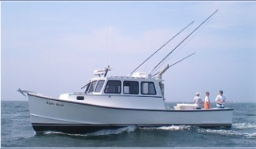 | Capt. Bob Veach | (860) 917-8688 | 6 passenger
Marlintini  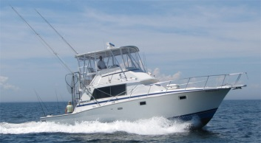 | Capt. Rick Roy | (860) 917-5893 | 6 passenger
Hel-Cat II  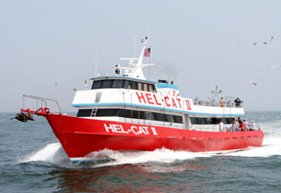 | Capt. Brad Glas | (860) 535-2066 | 80 passenger
The Fever  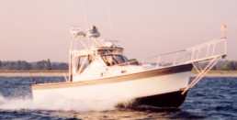 | Capt. Paul Bengston | (860) 537-0307 | 6 passenger
Otter  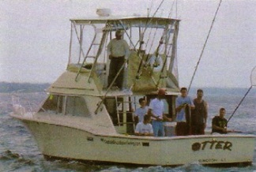 | Capt. Bruce Millar | (860) 235-6095 | 6 passenger
Playin' Hooky  No Picture provided | Capt. Bob DeMagistris | (413) 529-0518 | 6 passenger
Good Company II | Capt. Doug Parker | (860) 430-4463 | 6 passenger
Helen III  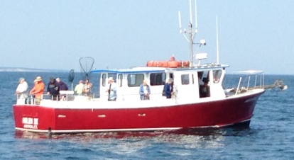 | Capt. Preston Glas | (860) 460-8793 | 25 passenger
Carolyn Ann  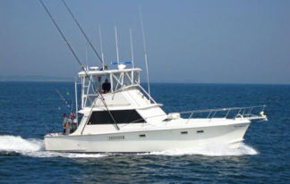 | Capt. Andy McGurer | (860) 884-1702 | 6 passenger
Blue Venture Fishing | Capt. Doug Luginbuhl | (860)798-6629 | 6 passenger
Valiant Lady  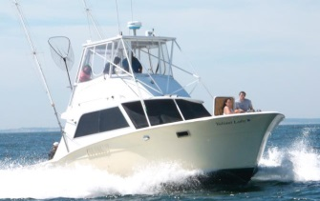 | Capt. Don Adams | (860) 874-8719 | 6 passenger
NOANK / MYSTIC / STONINGTON
Mataura | Capt. Tom McLoughin | (860) 536-6970 | 6 passenger
Magic | Capt. David Keeney | (860) 455-9942 | 6 passenger
Emma L  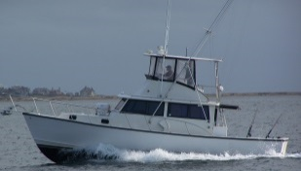 | Capt. Arthur Burton | (401) 742-0438 | 6 passenger
NIANTIC / WATERFORD
Sunbeam V  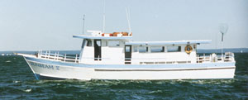 | Capt. Bob Wadsworth | (860) 443-7259 | 40 passenger
Sunbeam IV / Grumpa  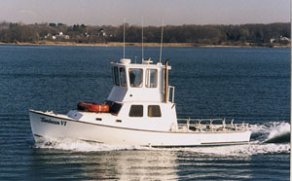  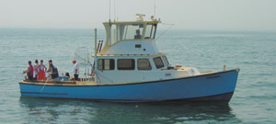 | Capt. Bob Wadsworth | (860) 443-7259 | 6-15 passenger  6 passenger
Release One  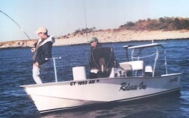 | Capt. Randy Jacobson | (860) 437-9768 | Fly/Light Tackle  3 - 4 passenger
Lucky Strike | Capt. Marc Berger | (860) 739-3535 | 6 passenger
Dot - E - Dee / J&B  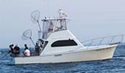  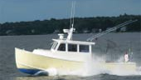 | Capt. Kerry Douton | (860) 739-7419 | 6 passenger  6 passenger
Southbound  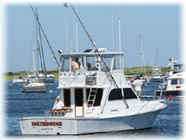 | Capt. Harry Angier | (860) 227-0726 | 6 passenger
Mijoy  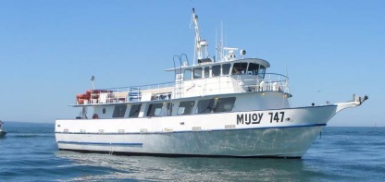 | Capt. Paul Brockett | (860) 443-0663 | 50 passenger
Black Hawk II  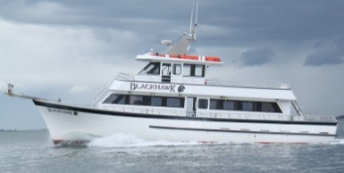 | Capt. Greg Dubrule | (860) 448-3662 | 60 passenger
Sunbeam Too  No Picture provided | Capt. John Wadsworth | (860) 428-7517 | 6 passenger

BRANFORD / CLINTON
Rock and Roll  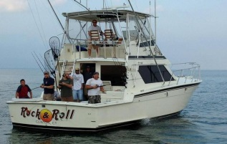 | Capt. TJ Karbowski | (203) 314-3765 | 6 passenger
Bluefin  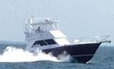 | Capt. Mike Marro | (877) 259-9920 | 6 passenger
Fish On | Capt. John Dugay | (203)-484-0784 | Fly/Light Tackle  3 - 4 passenger
FlyingConnie | Capt. Mike Pirri | (203)-515-1444 | 6 passenger
BRIDGEPORT / STAMFORD / NORWALK
Judith Lynn  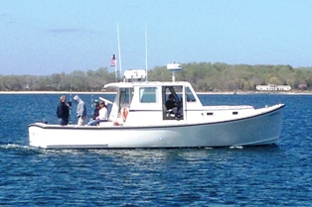 | Capt. Frankie Lanzo | (203) 246-6662 | 6 passenger
Middlebank  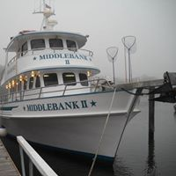 | Capt. Lauren Griffith | (203) 550-5967 | 60 Passengers
Deborah Ann IV  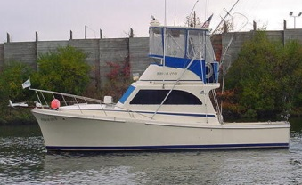 | Capt. Brian Hocking | (203) 792-2277 | 6 passenger
WESTBROOK / OLD SAYBROOK
Reelentless  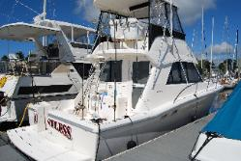 | Capt. Ed Noble | (413) 229-2105 | 6 passenger

Eden  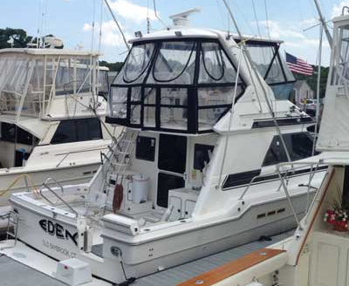 | Capt. Paul Retano | (860) 388-5897 | 6 passenger

